Project Journal — J_AI
Phase 1 — Linux Environment Setup
Installed Ubuntu 24.04 LTS inside WSL2 and configured a Linux development environment within Windows. Updated system packages and installed essential development tools including build utilities, Git, curl, Python venv, and pip to prepare for backend and AI development.
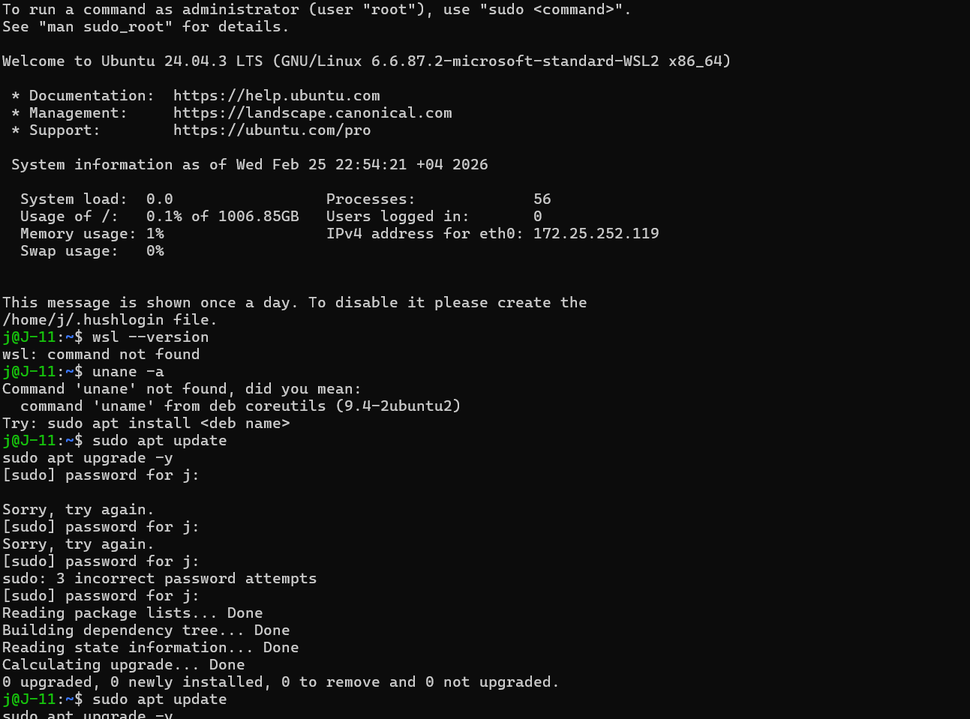
Result:
Ubuntu 24.04 LTS successfully initialized inside WSL2 with updated packages and required development tooling installed.
Outcome:
A stable Ubuntu 24.04 WSL2 environment configured for backend and AI development.

Phase 2 — System Access & Validation
Reset Ubuntu user credentials to ensure proper administrative access. Verified system functionality and confirmed Python 3.12.3 installation for development readiness.
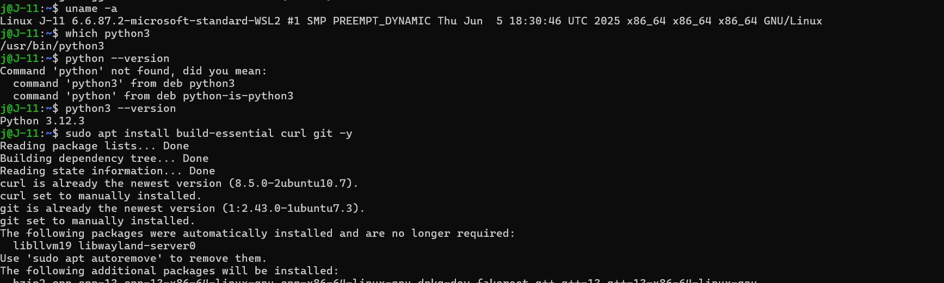
Result:
Administrative access restored and verified. Python 3.12.3 confirmed operational within WSL environment.
Outcome:
Secure and accessible Linux development environment.

Phase 3 — Ollama Installation
Installed Ollama inside the Ubuntu WSL environment. Resolved missing dependency issues by installing zstd. Verified successful installation using version check and confirmed local runtime availability.
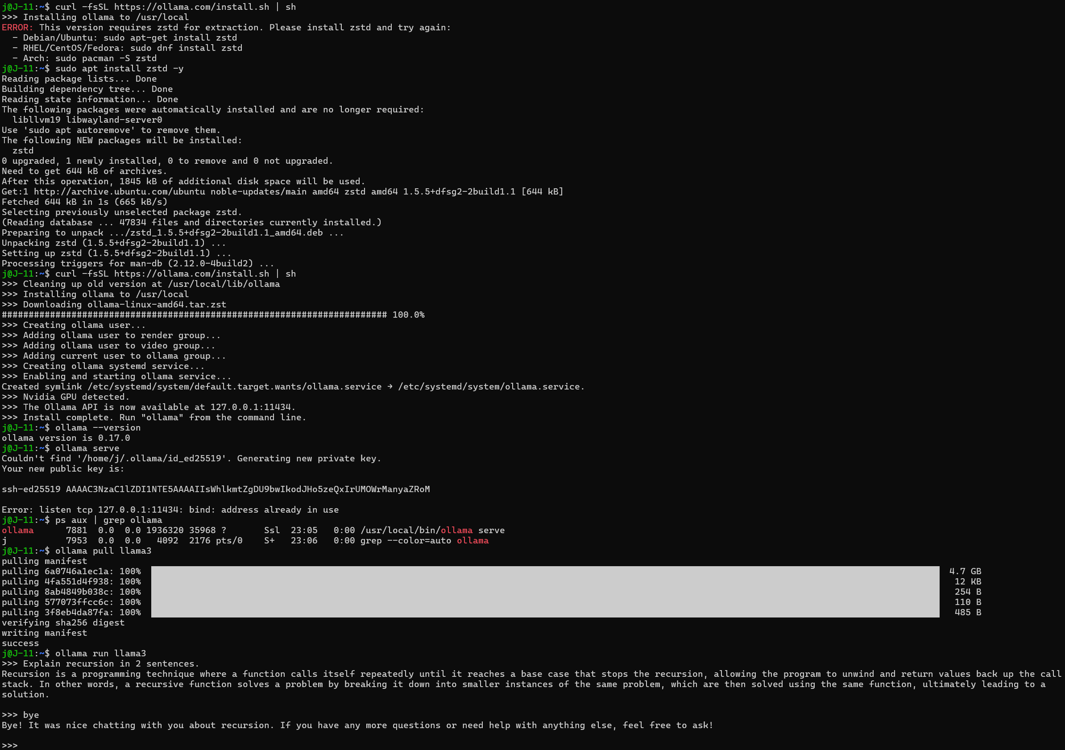
Result:
Model returned correct structured explanation.
Outcome:
Local LLM inference fully operational inside Ubuntu WSL environment.

Phase 4 — Local Model Verification
Pulled the llama3 model and validated local inference capability by executing structured test prompts through the Ollama CLI. Confirmed correct model response and runtime stability.
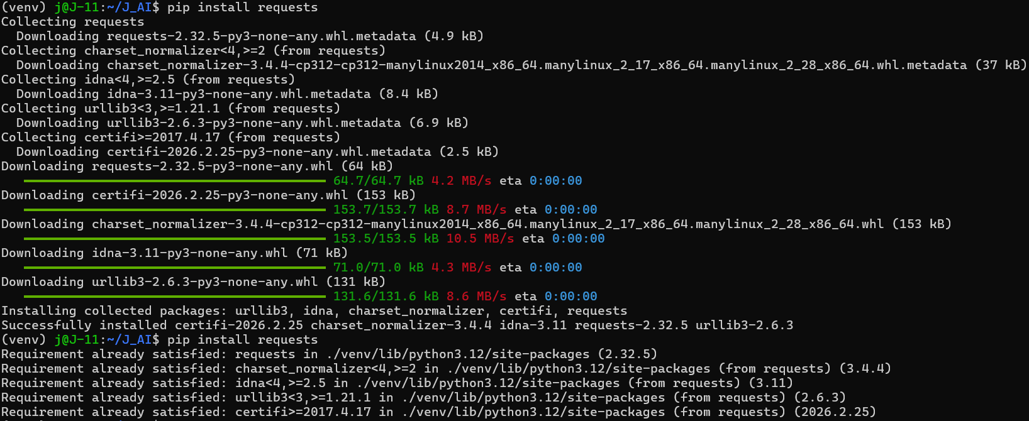
Result:
llama3 model successfully pulled and executed through Ollama CLI. Test prompt returned coherent, structured output, confirming stable local inference and active runtime service.
Outcome:
Confirmed functional local LLM runtime inside Ubuntu WSL, establishing a stable foundation for programmatic integration.

Phase 5 — Python Provider Integration
Implemented a modular Ollama provider using REST API communication from within a structured Python project. Established application controlled inference by sending HTTP POST requests to the local Ollama server, handling JSON responses, and integrating the provider into an interactive CLI interface.
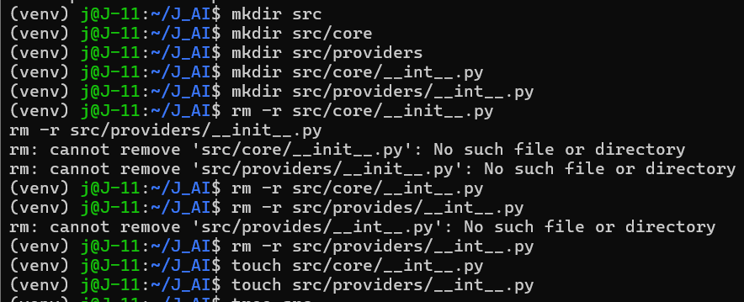
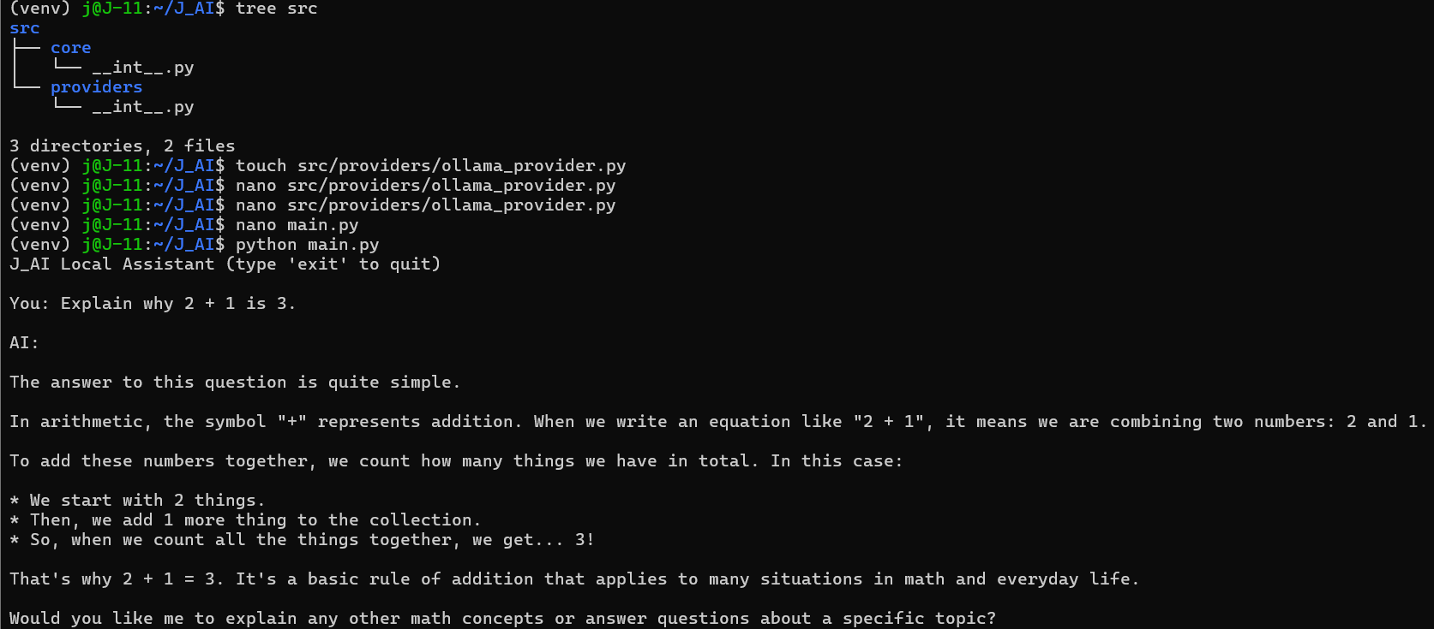
Result:
Custom Python application successfully generated model responses via programmatic API calls to the local Ollama runtime.
Outcome:
Transitioned from manual CLI interaction to structured backend driven AI architecture, enabling future provider abstraction and seamless model switching.
Phase 6 — Provider Abstraction Layer
Implemented abstract base provider interface and refactored Ollama provider to inherit from it, enforcing consistent generation contract across future AI backends.
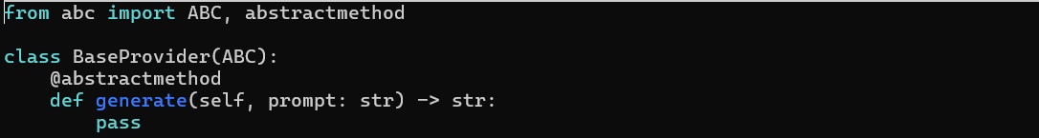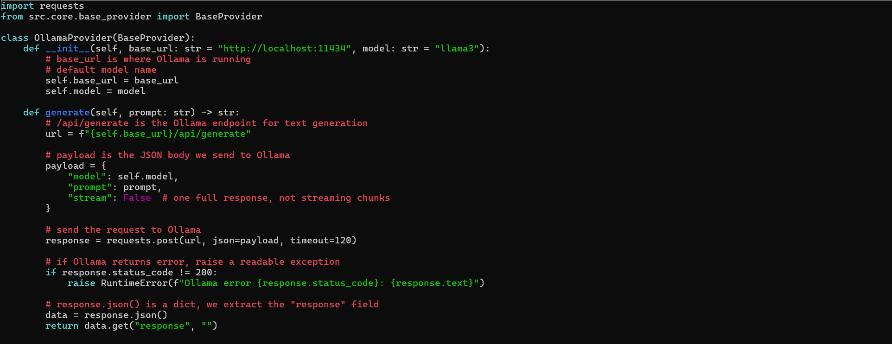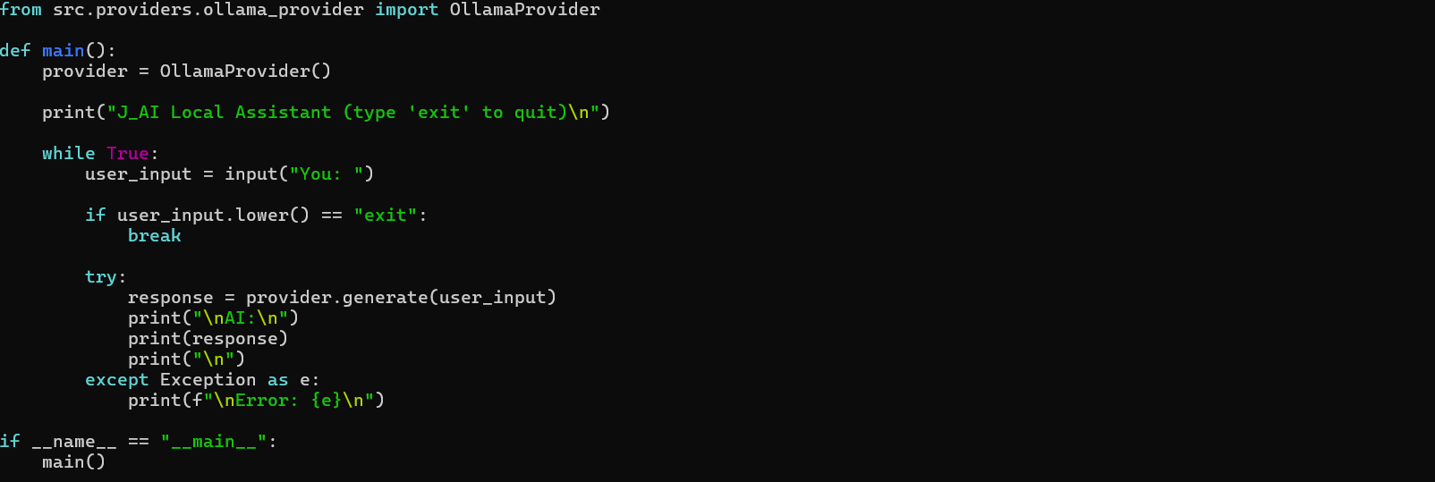
Result:
Application successfully executed with abstracted provider architecture and no runtime regression.
Outcome:
Established provider agnostic AI system foundation, enabling seamless future integration of GPT or other inference engines without modifying core logic.

Phase 7 — Provider Factory Implementation
Introduced provider factory layer to decouple application logic from specific AI backend. Implemented environment based provider selection mechanism using JAI_PROVIDER configuration variable.
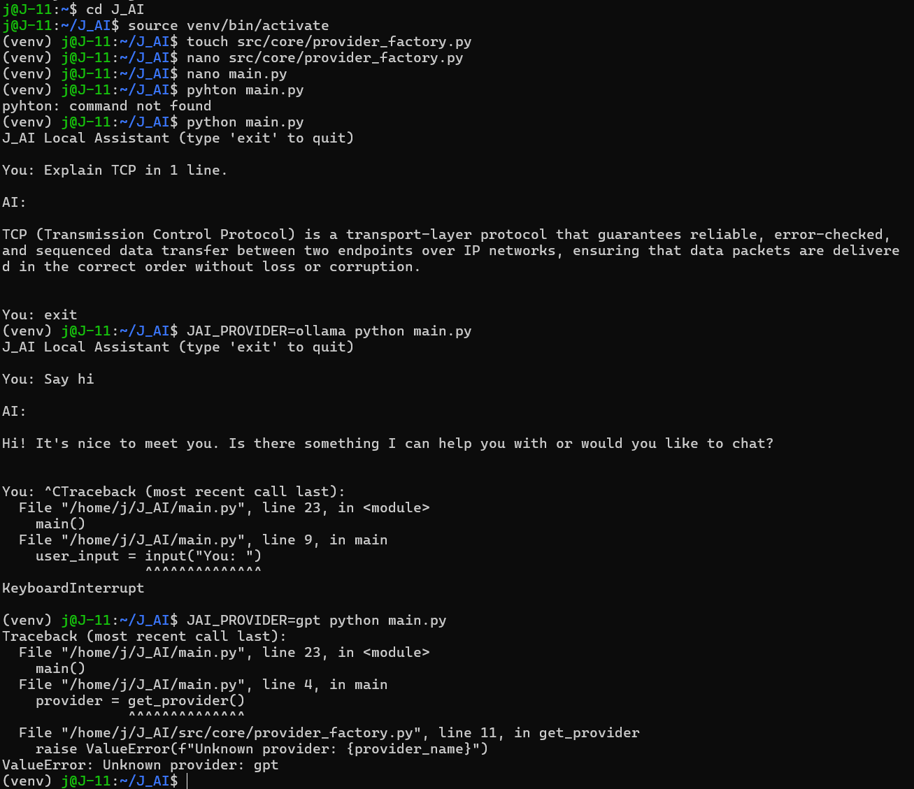
Result:
Application successfully instantiated providers dynamically without direct dependency on Ollama class.
Outcome:
Established backend agnostic AI system architecture, enabling seamless expansion to GPT or additional providers without modifying entry point logic.

Phase 8 Part 1 — GPT attempt
Tried integrating GPT provider using OpenAI API key authentication. Key validation succeeded, but requests failed due to insufficient quota. Continued development using local Ollama runtime to keep the project fully offline and cost free.
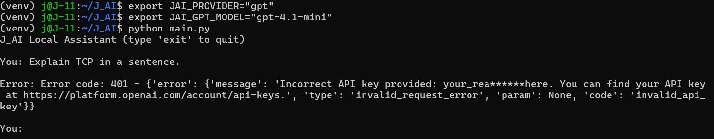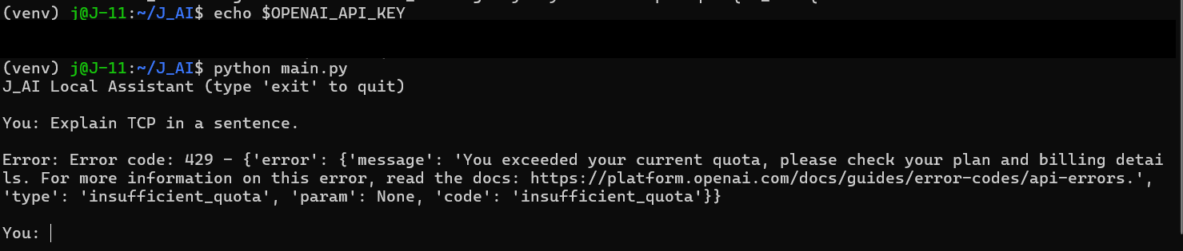
Result:
OpenAI API calls returned insufficient quota error and could not complete GPT provider verification.
Outcome:
Kept architecture provider ready while maintaining a fully local runtime for study and development.

Phase 8 Part 2 — Configuration Layer
Implemented .env based configuration loading using python dotenv. Refactored providers to read runtime configuration from environment variables instead of hardcoded defaults. Resolved environment precedence conflict between shell exports and .env values.
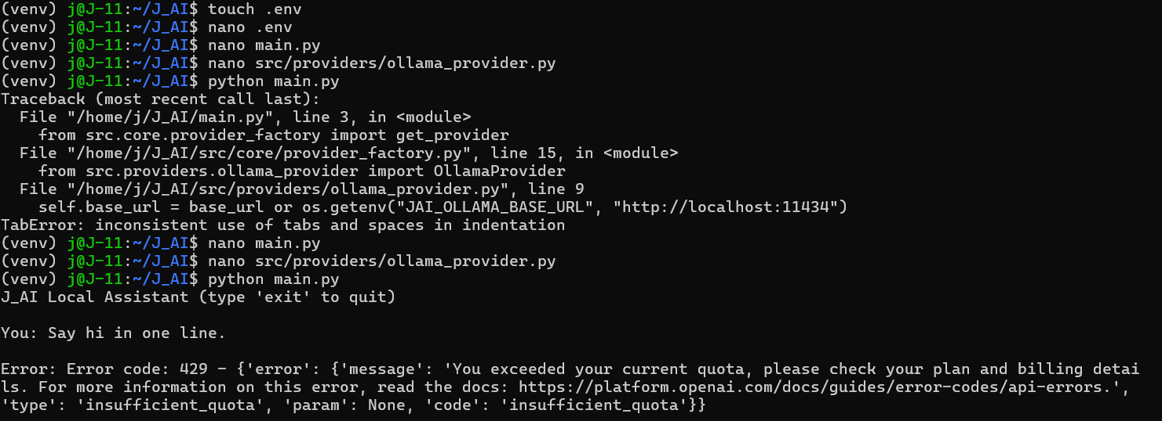
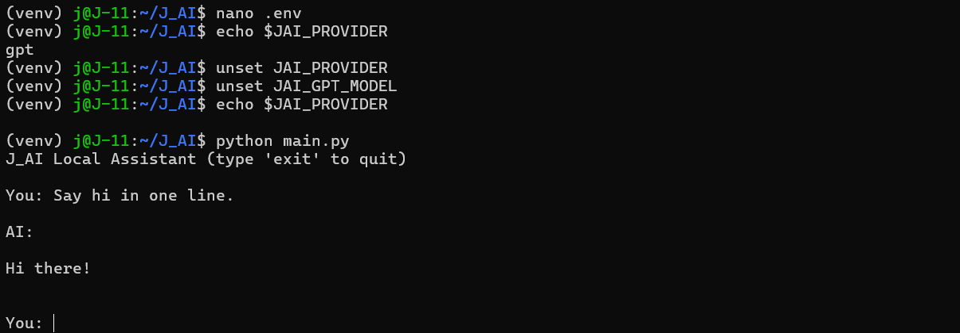
Result:
Application correctly selected provider based on .env configuration without manual terminal exports.
Outcome:
Established centralized configuration system enabling clean environment controlled runtime behavior.

